Lab 3 Viewing
Eva Nolan
14335043
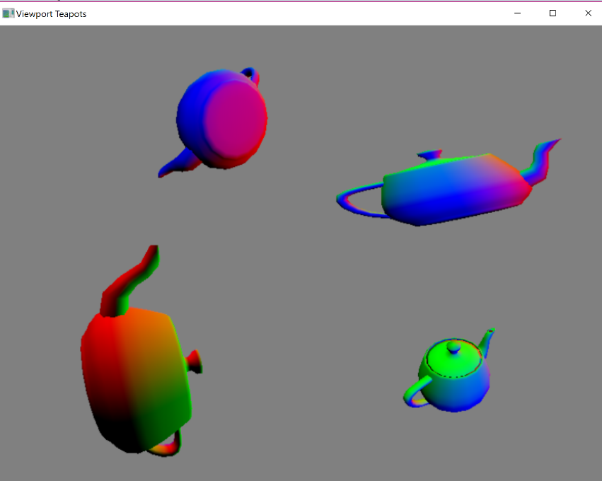

Perspective Projections
The bottom left and bottom right and top right viewports both help perspective projections. These were achieved using the perspective projection function in maths_funcs.cpp
I created one teapot which appears to be moving. I achieved this by changing the angle at which the model was projected with respect to time using the getGetTime() function. The model appears to rotate about the x, y and z axis.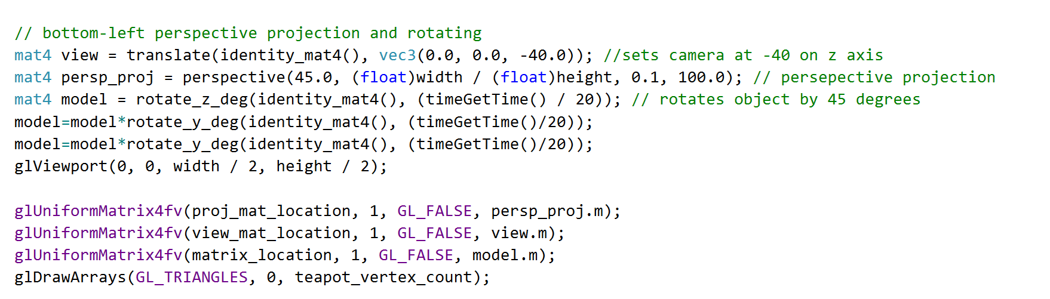
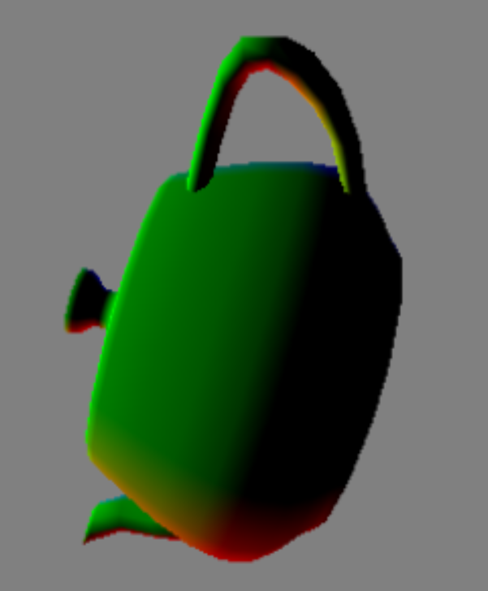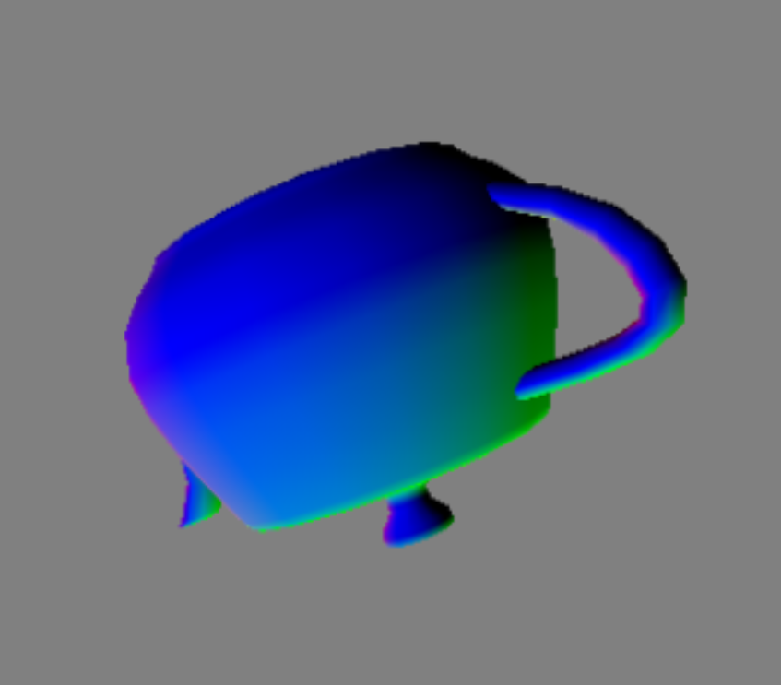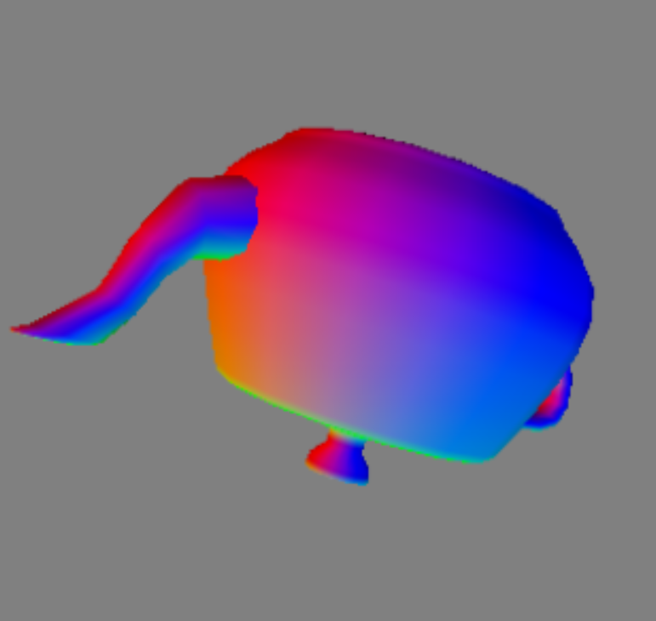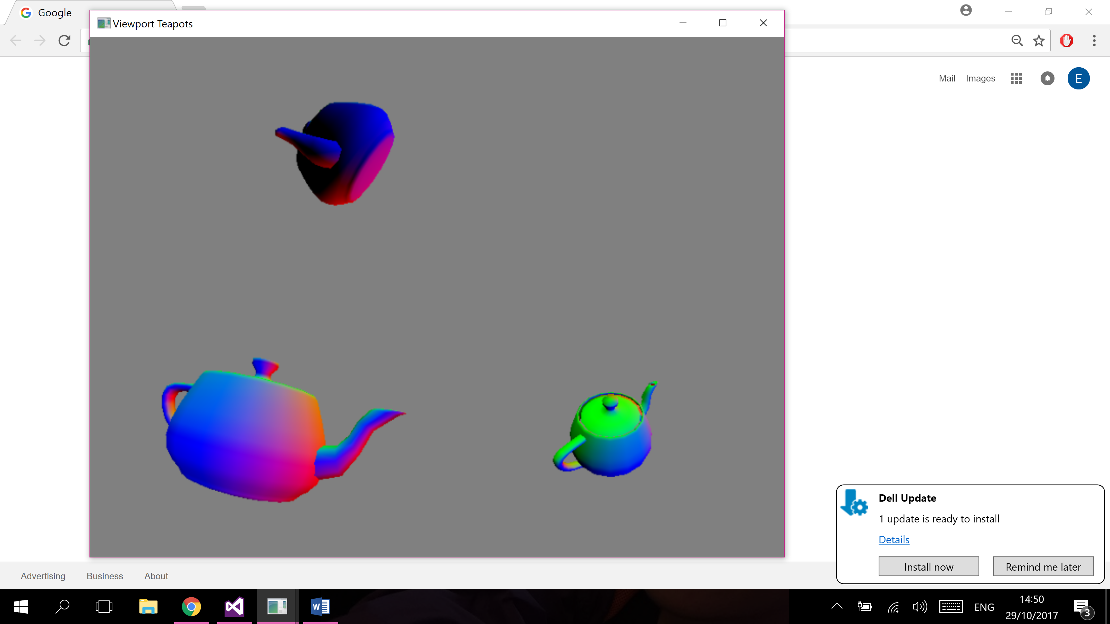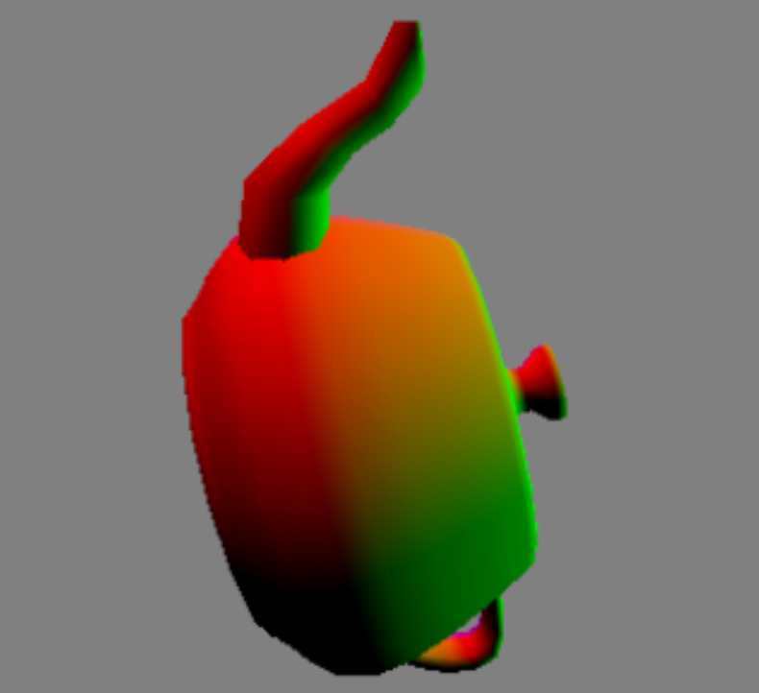

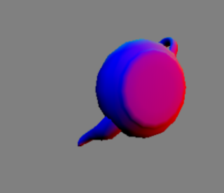
The second perspective projection I achieved was static. It also used the provided look_at function. I also chose to rotate the model about the x and y axis to give an image of the model from a different side and make the four viewports together more interesting to look at.
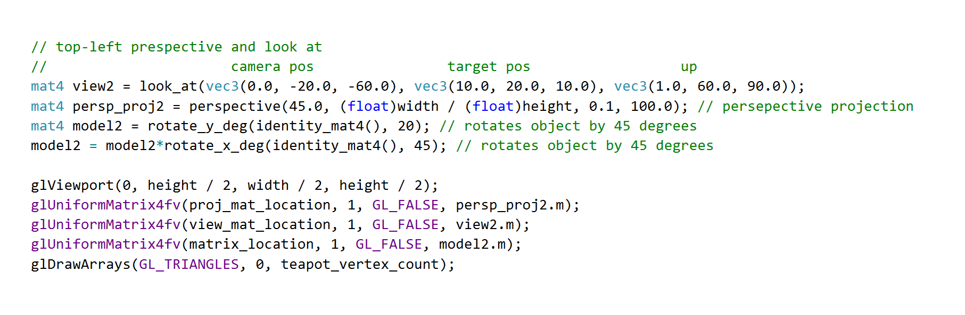
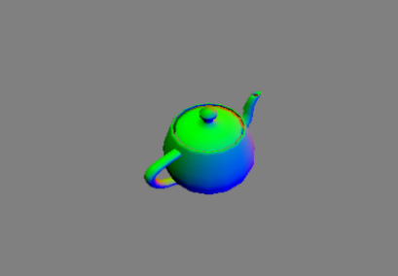
The third presepective projection was was again rotated to show another angle of the teapot. I also changed the fovy so the teapot appears father away in the scene.
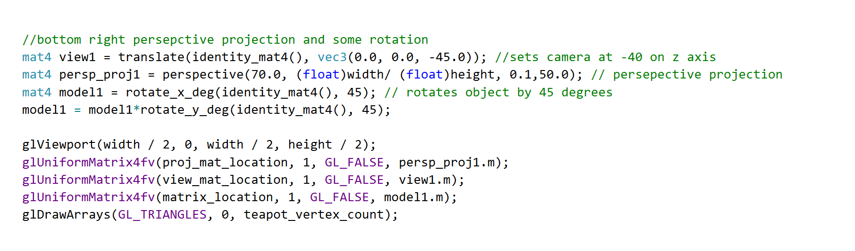
Orthographic Projection
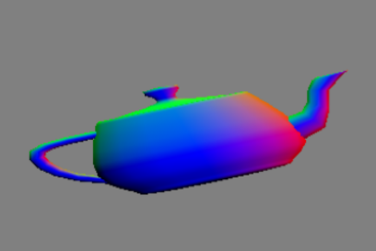
The orthographic projection was the most difficult to achieve as it was necessary to create a projection matrix. I wrote an orthographic projection function based on the projection functions in maths_funcs.cpp and orthographic projection algebra. This function was then called to create the projection matrix.


